**Assignment 4.3**

**Ques:1. States = rownames(US Arrests)**

**Get states names with ‘w’.**

**Get states names with ‘W’.**

**Ans:-**

USArrestsnames<-data.frame(USArrests$X)

USArrestsnames

USArrestsnames[grep("^w",USArrestsnames$USArrests),]

USArrestsnames[grep("^W", USArrestsnames$USArrests),]

OUTPUT:-

USArrests.X (X=states)

1 Alabama

2 Alaska

3 Arizona

4 Arkansas

5 California

6 Colorado

7 Connecticut

8 Delaware

9 Florida

10 Georgia

11 Hawaii

12 Idaho

13 Illinois

14 Indiana

15 Iowa

16 Kansas

17 Kentucky

18 Louisiana

19 Maine

20 Maryland

21 Massachusetts

22 Michigan

23 Minnesota

24 Mississippi

25 Missouri

26 Montana

27 Nebraska

28 Nevada

29 New Hampshire

30 New Jersey

31 New Mexico

32 New York

33 North Carolina

34 North Dakota

35 Ohio

36 Oklahoma

37 Oregon

38 Pennsylvania

39 Rhode Island

40 South Carolina

41 South Dakota

42 Tennessee

43 Texas

44 Utah

45 Vermont

46 Virginia

47 Washington

48 West Virginia

49 Wisconsin

50 Wyoming

USArrestsnames[grep("^w",USArrestsnames$USArrests),]

factor(0)

50 Levels: Alabama Alaska Arizona Arkansas California Colorado Connecticut ... Wyoming

USArrestsnames[grep("^W", USArrestsnames$USArrests),]

[1] Washington West Virginia Wisconsin Wyoming

50 Levels: Alabama Alaska Arizona Arkansas California Colorado Connecticut ... Wyoming

Note:- ‘X’ is the name of the USA states.

**Ques:2.** **Prepare a Histogram of the number of characters in each US state.**

hist(USArrests$Murder , col = "red")

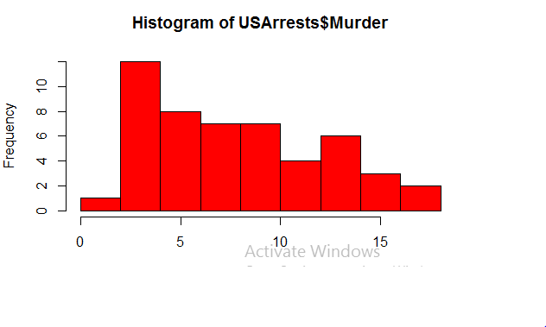

hist(USArrests$Assault , col = "blue")

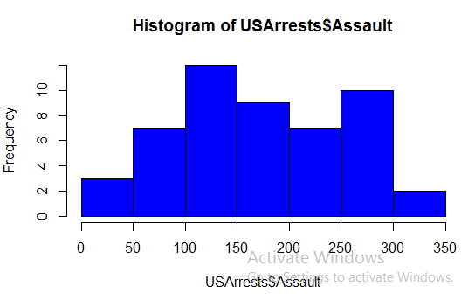

hist(USArrests$UrbanPop , col = "green")

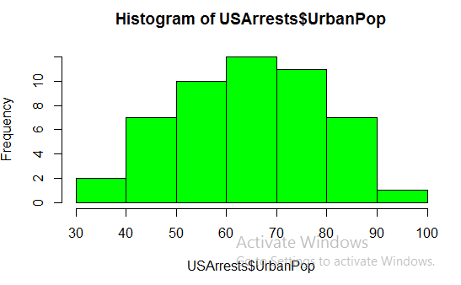

hist(USArrests$Rape , col = "black")

